Linear-Regression–Part1.R
R Roseline Mary
2021-02-01
str(cars)
## 'data.frame': 50 obs. of 2 variables:
## $ speed: num 4 4 7 7 8 9 10 10 10 11 ...
## $ dist : num 2 10 4 22 16 10 18 26 34 17 ...
nrow(cars)
## [1] 50
ncol(cars)
## [1] 2
length(cars)
## [1] 2
head(cars)
## speed dist
## 1 4 2
## 2 4 10
## 3 7 4
## 4 7 22
## 5 8 16
## 6 9 10
scatter.smooth(x=cars$speed, y=cars$dist, main="Dist ~ Speed") # scatterplot
#attach(mtcars)
library(lattice)
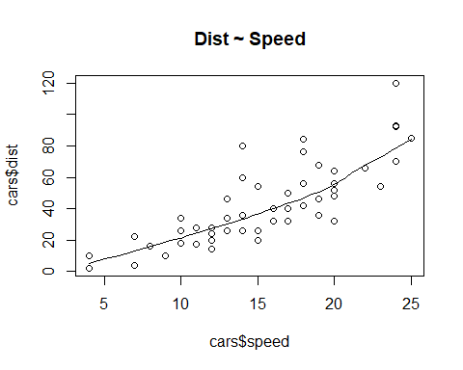
boxplot(cars$speed, main="Speed")
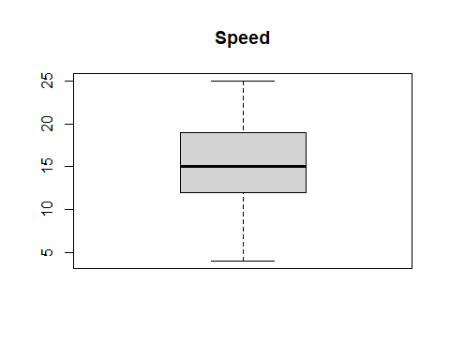
boxplot(cars$dist, main="Distance")
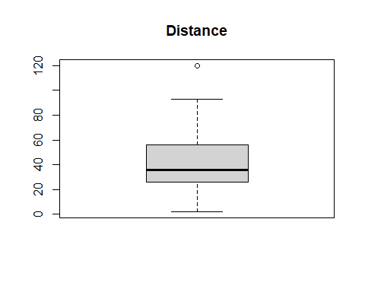
library(e1071) # for skewness function
par(mfrow=c(1,2)) # divide graph area in 2 columns
library(e1071)
plot(density(cars$speed), main="Density Plot: Speed", ylab="Frequency",sub=paste("Skewness:",round(e1071::skewness(cars$speed),2))) # density plot for 'speed'
polygon(density(cars$speed), col="red")
plot(density(cars$dist), main="Density Plot: Distance", ylab="Frequency")
sub=paste("Skewness:", round(e1071::skewness(cars$dist), 2)) # density plot for 'dist'
polygon(density(cars$dist), col="red")
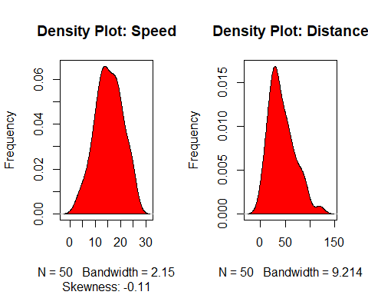
cor(cars$speed, cars$dist)
## [1] 0.8068949
linearMod <- lm(dist ~ speed, data=cars)
linearMod
##
## Call:
## lm(formula = dist ~ speed, data = cars)
##
## Coefficients:
## (Intercept) speed
## -17.579 3.932
summary(linearMod)
##
## Call:
## lm(formula = dist ~ speed, data = cars)
##
## Residuals:
## Min 1Q Median 3Q Max
## -29.069 -9.525 -2.272 9.215 43.201
##
## Coefficients:
## Estimate Std. Error t value Pr(>|t|)
## (Intercept) -17.5791 6.7584 -2.601 0.0123 *
## speed 3.9324 0.4155 9.464 1.49e-12 ***
## ---
## Signif. codes: 0 '***' 0.001 '**' 0.01 '*' 0.05 '.' 0.1 ' ' 1
##
## Residual standard error: 15.38 on 48 degrees of freedom
## Multiple R-squared: 0.6511, Adjusted R-squared: 0.6438
## F-statistic: 89.57 on 1 and 48 DF, p-value: 1.49e-12
#capture model summary as an object
modelsummary<-summary(linearMod)
modelsummary
##
## Call:
## lm(formula = dist ~ speed, data = cars)
##
## Residuals:
## Min 1Q Median 3Q Max
## -29.069 -9.525 -2.272 9.215 43.201
##
## Coefficients:
## Estimate Std. Error t value Pr(>|t|)
## (Intercept) -17.5791 6.7584 -2.601 0.0123 *
## speed 3.9324 0.4155 9.464 1.49e-12 ***
## ---
## Signif. codes: 0 '***' 0.001 '**' 0.01 '*' 0.05 '.' 0.1 ' ' 1
##
## Residual standard error: 15.38 on 48 degrees of freedom
## Multiple R-squared: 0.6511, Adjusted R-squared: 0.6438
## F-statistic: 89.57 on 1 and 48 DF, p-value: 1.49e-12
#modelCoefficients
modelCoeffs <- modelsummary$coefficients
print(modelCoeffs)
## Estimate Std. Error t value Pr(>|t|)
## (Intercept) -17.579095 6.7584402 -2.601058 1.231882e-02
## speed 3.932409 0.4155128 9.463990 1.489836e-12
#estimate for speed
estimate<-modelCoeffs["speed","Estimate"]
print(estimate)
## [1] 3.932409
#standard error for speed
std.error<-modelCoeffs["speed","Std. Error"]
print(std.error)
## [1] 0.4155128
#calculating t-statistics
t_value <- estimate/std.error
#calculating p-value
#pt denotes the cumulative density function of the t-distribution and df is the number of degrees of freedom
#Here the degrees of freedom is (length of the cars is 50-1=49)
p1_value<-2*pt(-abs(t_value),df=length(cars$dist)-1)
p1_value
## [1] 1.213299e-12

